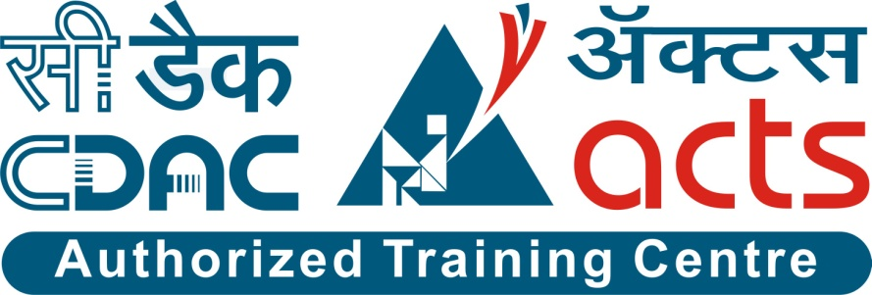

Project Name: Learning Management System

Branch PG-DAC Mar-2023

Documentation On

**“**Learning Management System**”**

PG-DAC March 2023

Guide By: Dipali Jadhav

Submitted By:

**Group No: 27**

**Shailesh Agarmore 230343020005**

**Sushil Chaudhari 230343020023**

**Pranav Chirame 230343020024**

**Shantanu Mundhe 230343020060**

**Table of Contents**

**1. Introduction 4**

1.1 Document Purpose **4**

1.2 Project Background **4**

1.3 Aim & Objectives **4**

**2. Business Requirements Overview**…………………………………………………………**5**

**3.Functional Requirements** **6**

3.1 Admin Module **6**

3.2 Trainers Module **6**

3.3 Students Module **6**

**4.** **Non-Functional Requirement………………………………………………………………7**

**5. Use Case Diagram 8**

5.1 Admin **9**

5.2 Trainers **10**

5.3 Students **11**

**6. Database Design 12**

1 assignments **12**

2 course **12**

3 password_reset_tokens **12**

4 roles **13**

5 students **13**

6 student_courses **13**

7 trainers **13**

8 trainers_courses **13**

9 users **14**

10 users_roles **14**

**7. E-R Diagram………………………………………………………………………………………14**

**8. Snapshots 15**

**9. Conclusion 20**

**List of Figures**

**Use Case Diagrams 17**

Fig 1 Admin 8

Fig 2 Trainers 9

Fig 3 Students 10

Fig 4 ER Diagram 14

1. **Introduction:**
   1. **Document Purpose:**

This document communicates the business requirements and scope for developing Leaning Management System. The scope of this document is to define the functional and non-functional requirements, business rules and other constraints requirements.

## Project Background:

Learning Management System is the simple web application for a graduation college which facilitates the goal of ease of learning in the education sector. The main objective of the project is to develop a web application that provides a smart and easy way for the execution of several academic operations to help students as well as teachers in managing daily activities of campus. The system will maintain the data of students and trainers, Attendance, Time Table, Assignments, Submission, Academic Data etc.

Trainers and Students will have privileges according to their designations and have rights to post things on application so that other users can view it if they have permission to view it. The system helps in managing and conveying the data easily which would have been time consuming and difficult to manage manually.

## Aim & Objectives:

The main objective of this system is building a website which improves user accessibility and time flexibility to the daily routine of campus. In this project we are providing daily time table, course material, upload assignments on daily basis etc. The key benefit of Learning Management System is to maintain all the daily routine of campus virtually. It can help students as well as Trainers in multiple ways for effective learning.

1. **Business Requirements Overview:**

* Learning Management System is maintained by Admin and Manage the daily routine of campus in multiple ways.
* Learning Management System is opened to the global, but in phase 1, the main target is a one campus only.
* There are mainly two types of user. One is the Trainer and other is Student.
* Trainers can see their time table, upload course material, maintain student record.
* Uploading assignments for students on daily basis.
* Students also can see their timetable, uploaded assignments, and their performance as well.

# Functional Requirements Overview:

Learning Management System consists of three modules described as below.

1. Admin Module
2. Trainer Module
3. Student Module

# **3.1 Admin** **Module**

* Admin will able to manage data about teacher and students.
* Admin will have login first before the accessing those details.
* Login credential of teachers and students will allow by the admin.
* Learning Management System provides the functionalities like daily time table and study material for students for every session.

# **Trainer Module**

* Trainer provides the functionality which allows to upload course related material on daily basis.
* Upload assignments for students and give them a grade on the performance basis.

# **3.3 Student Module**

* Learning Management System provides a virtual management of daily routine of campus and it helps a lot in too many ways.
* Student can have access to see course related material, daily assignments given by trainers and upload it after completion.

1. **Non-Functional Requirement:**

* The website should use professional design, look and feel and color scheme.
* Users will have no limitations for accessing the application through Internet.
* Being a public website, the site must follow general usability guidelines for menus, navigation, colors, links and other actions provided on the screens.
* The system should be designed in such a manner that user will be able to complete tasks in minimum number of steps.
* Fast loading times for pages and content delivery.
* Ability to handle increasing numbers of users, courses, and interactions.
* Clear privacy policy outlining how user data is collected, stored, and used.

## 5. Use-Case Diagram

**5.1 Admin:**

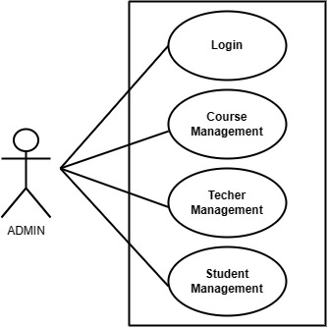

Fig. Use-Case Diagram for Admin

## 5.2 Trainer:

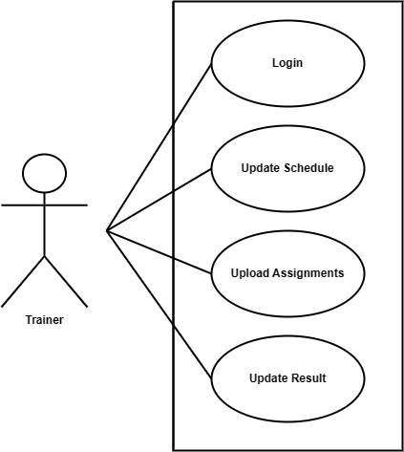

Fig. Use-Case Diagram for Trainer

**5.3 Student:**

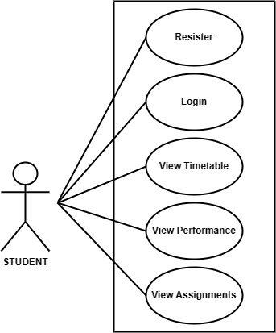

Fig. Use-Case Diagram for Student

**6. Database Design:**

1. **Assignment table**

|  |  |  |  |  |  |
| --- | --- | --- | --- | --- | --- |
| **users** | | | | | |
| Field | Type | Null | Key | Default | Extra |
|
| course_id | int | NO | PRI | NULL |  |
| assignment | varchar(255) | NO |  | NULL |  |
| Is_submitted | tinyint(1) | YES |  | 0 |  |
| Submission_date | datetime(6) | NO |  | NULL |  |

**2] courses table**

|  |  |  |  |  |  |
| --- | --- | --- | --- | --- | --- |
| **courses** | | | | | |
| Field | Type | Null | Key | Default | Extra |
|
| id | int | NO | PRI | NULL | auto_increment |
| has_attended_e_courses | tinyint(1) | YES |  | 0 |  |
| is_paid | tinyint(1) | YES |  | 0 |  |
| price | int | NO |  | NULL |  |
| semester | varchar(255) | YES |  | NULL |  |
| title | varchar(255) | NO |  | NULL |  |

**3] password_reset_tokens table**

|  |  |  |  |  |  |
| --- | --- | --- | --- | --- | --- |
| **password_reset_tokens** | | | | | |
| Field | Type | Null | Key | Default | Extra |
|
| id | int | NO | PRI | NULL | auto_increment |
| expiry_date | expiry_date6) | YES |  | NULL |  |
| token | varchar(255) | YES |  | NULL |  |
| user_id | int | NO | MUL | NULL |  |

**4] roles table**

|  |  |  |  |  |  |
| --- | --- | --- | --- | --- | --- |
| **roles** | | | | | |
| Field | Type | Null | Key | Default | Extra |
|
| id | int | NO | PRI | NULL | auto_increment |
| role | varchar(255) | YES | UNI | NULL |  |

**5] students table**

|  |  |  |  |  |  |
| --- | --- | --- | --- | --- | --- |
| **students** | | | | | |
| Field | Type | Null | Key | Default | Extra |
|
| user_id | int | NO | PRI | NULL |  |
| tuition_fees | bigint | NO |  | NULL |  |

**6] students_courses table**

|  |  |  |  |  |  |
| --- | --- | --- | --- | --- | --- |
| **students_courses** | | | | | |
| Field | Type | Null | Key | Default | Extra |
|
| student_id | int | NO | PRI | NULL |  |
| course_id | int | NO | PRI | NULL |  |

**7] trainers table**

|  |  |  |  |  |  |
| --- | --- | --- | --- | --- | --- |
| **trainers** | | | | | |
| Field | Type | Null | Key | Default | Extra |
|
| user_id | int | NO | PRI | NULL |  |
| subbject | varchar(255) | NO |  | NULL |  |

**8] trainers_courses table**

|  |  |  |  |  |  |
| --- | --- | --- | --- | --- | --- |
| **Trainer_courses** | | | | | |
| Field | Type | Null | Key | Default | Extra |
|
| trainer_id | int | NO | PRI | NULL |  |
| course_id | varchar(255) | NO |  | NULL |  |

**9] users table**

|  |  |  |  |  |  |
| --- | --- | --- | --- | --- | --- |
| **users** | | | | | |
| Field | Type | Null | Key | Default | Extra |
|
| id | int | NO | PRI | NULL | auto_increment |
| email | varchar(50) | NO | UNI | NULL |  |
| first_name | varchar(20) | NO |  | NULL |  |
| last_name | varchar(20) | NO |  | NULL |  |
| password | varchar(255) | NO |  | NULL |  |

**10] users_roles table**

|  |  |  |  |  |  |
| --- | --- | --- | --- | --- | --- |
| **users_roles** | | | | | |
| Field | Type | Null | Key | Default | Extra |
|
| User_id | int | NO | PRI | NULL |  |
| role_id | int | NO | PRI | NULL |  |

## ER-Diagram:

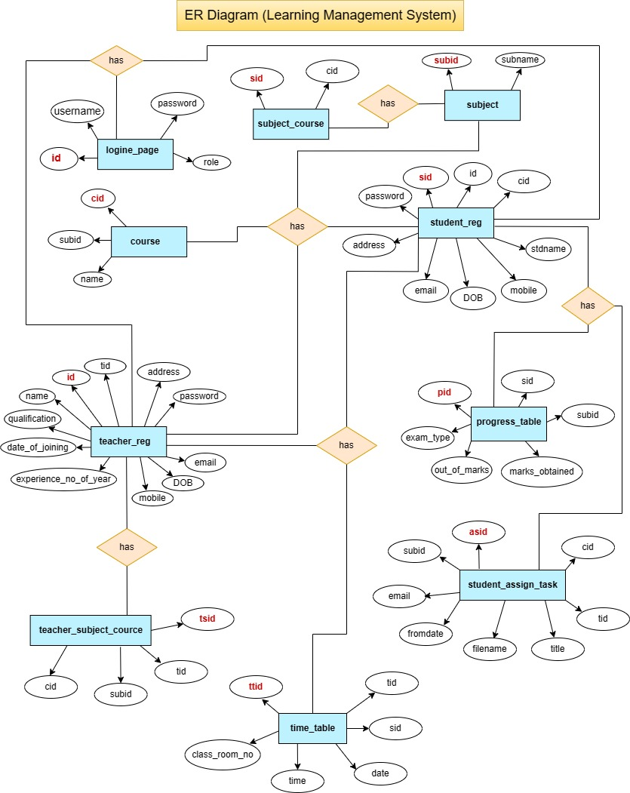

**8. Snapshots:**

**8.1 Home Page:**

Following snapshot shows the Home page for Learning Management System before Login.

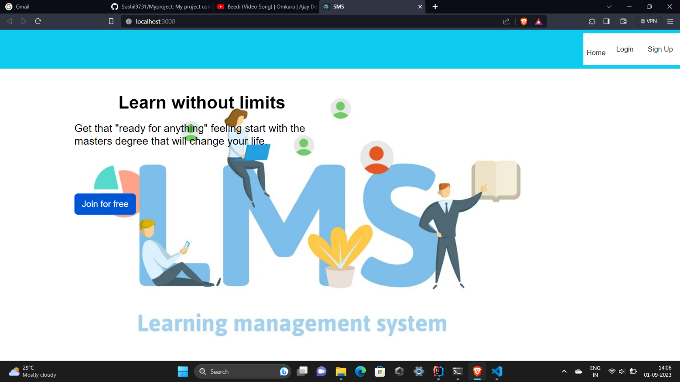

This page contains following controls

* Home
* Login
* Sign Up

**8.2 Admin Login**

**8.2.1 Admin Login**

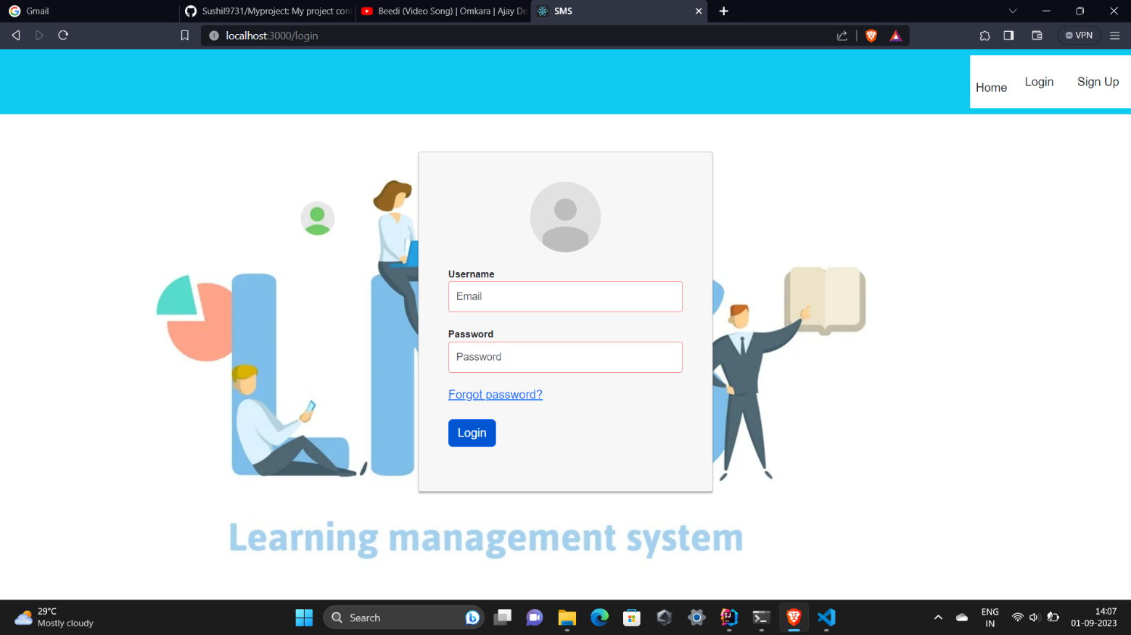

**8.2.2 Admin Dashboard**

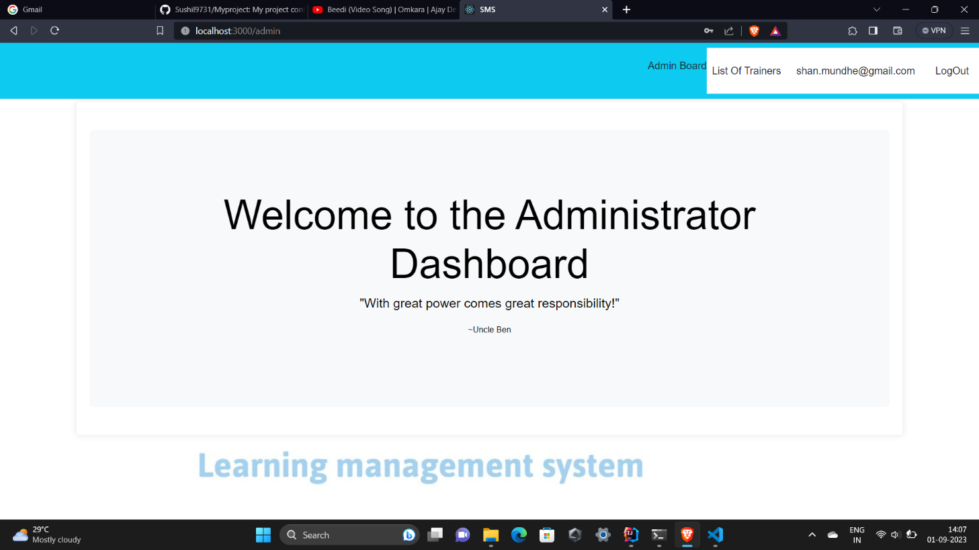

**8.2.3 Admin Profile**

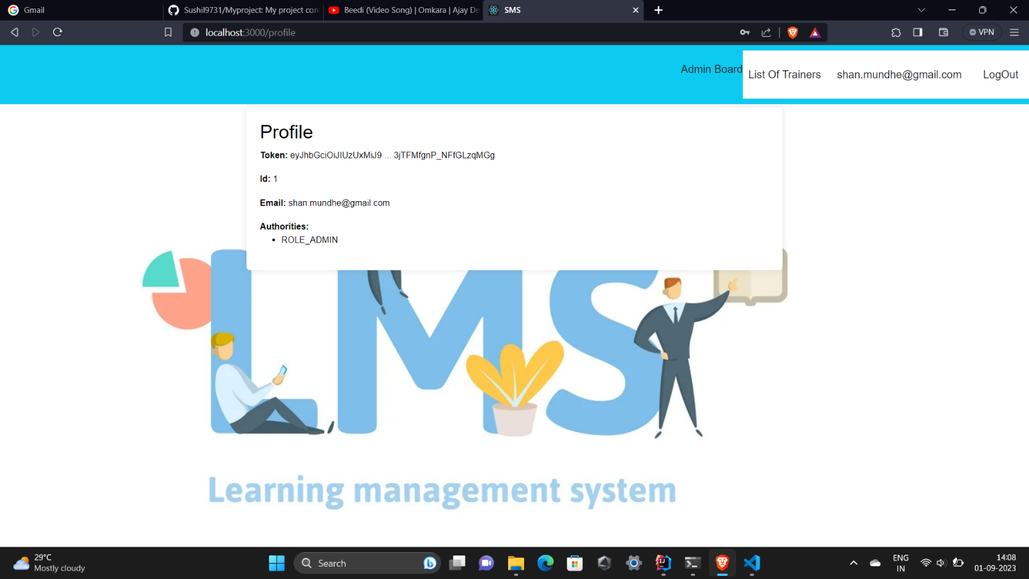

**8.2.4 List of Trainers added by Admin**

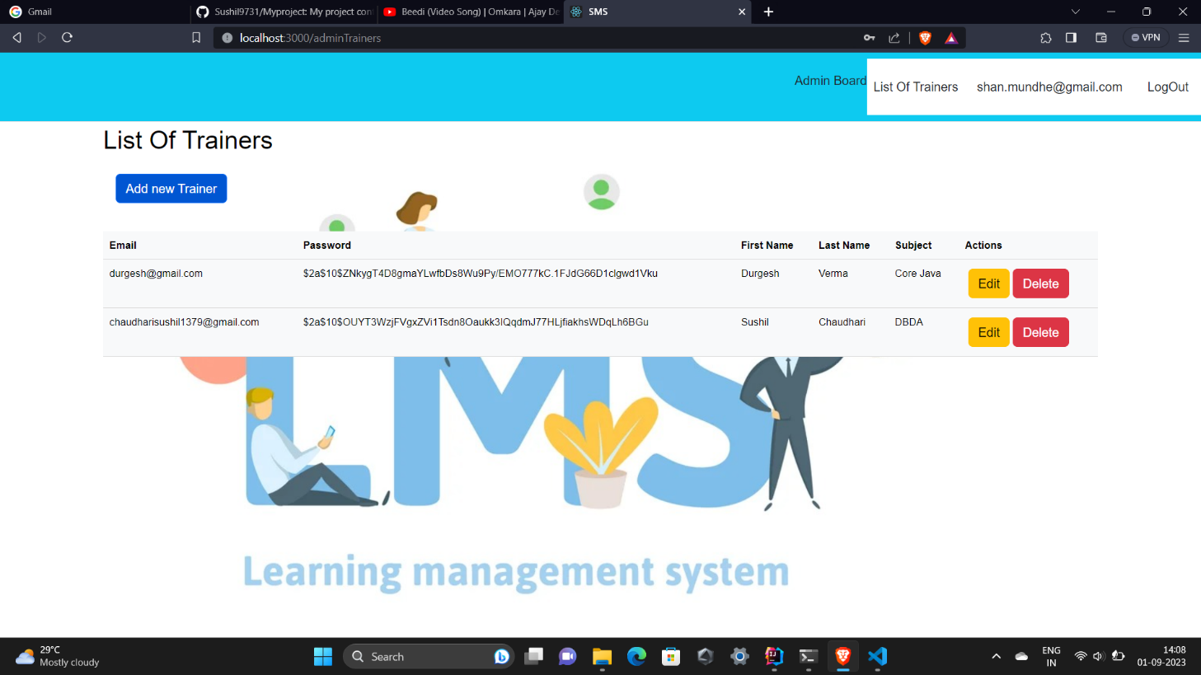

**8.3 Trainers Home Page**

**8.3.1 Home**

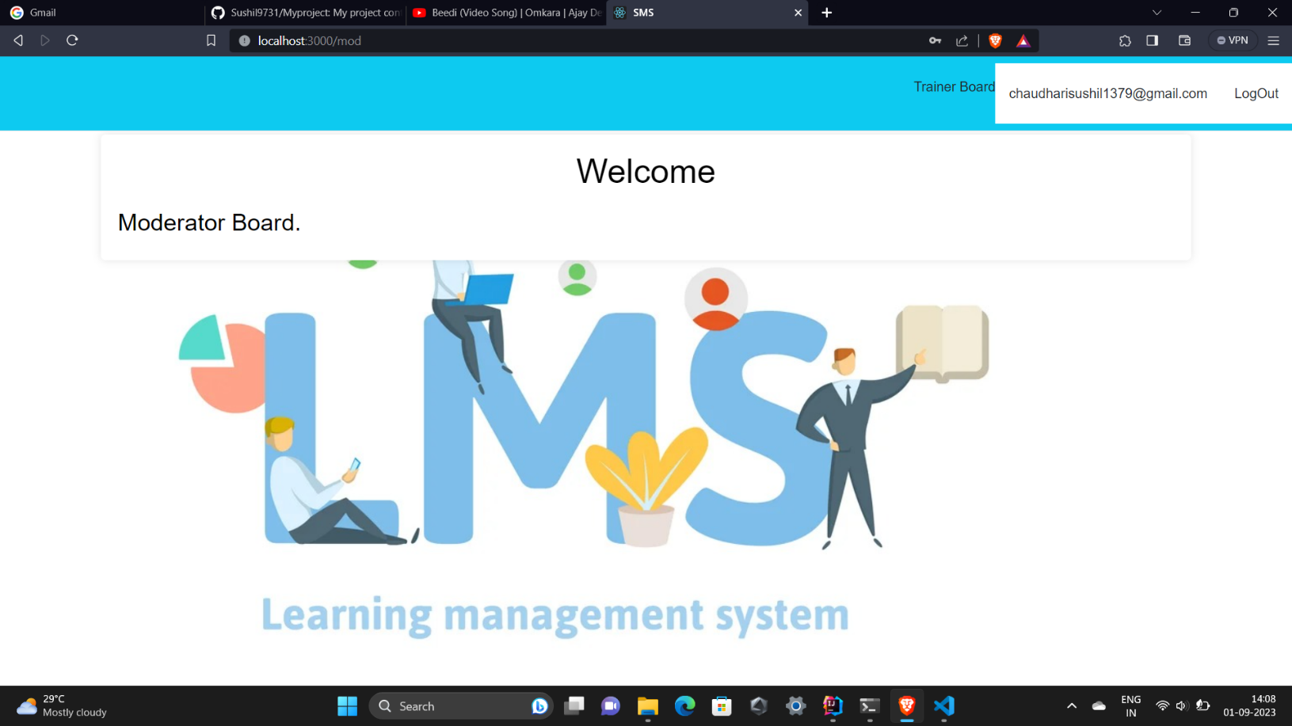

**8.3.2 Trainers Login**

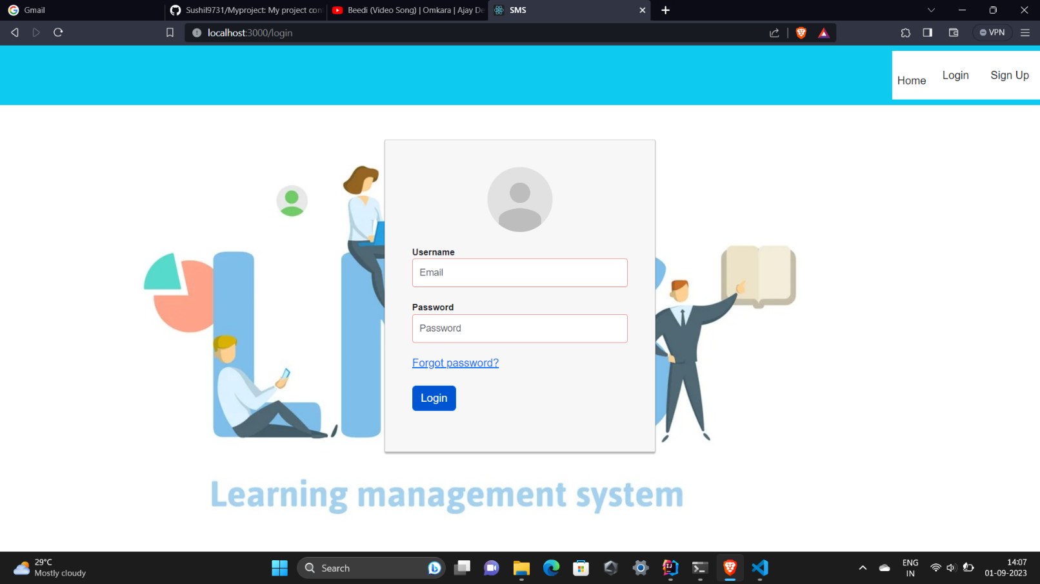

**8.3.3 Trainers Profile**

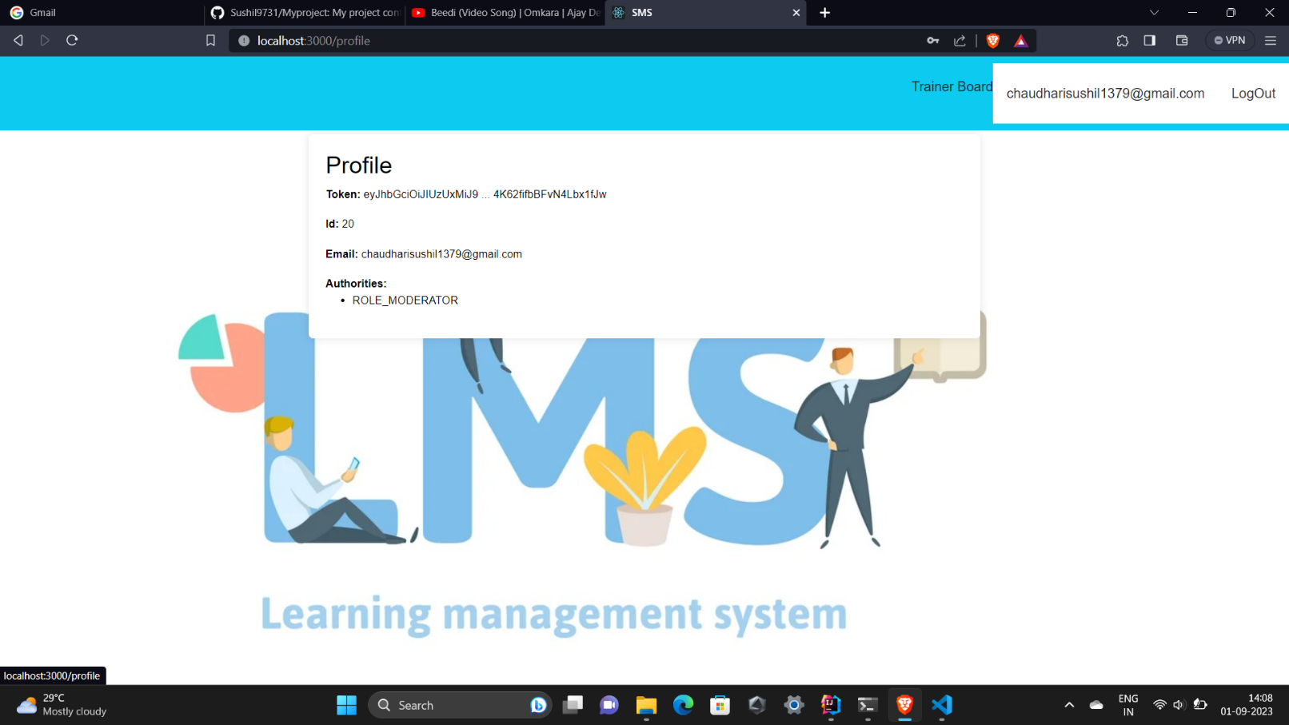

**8.4 Students Home Page**

**8.4.1 Students Registration Page**

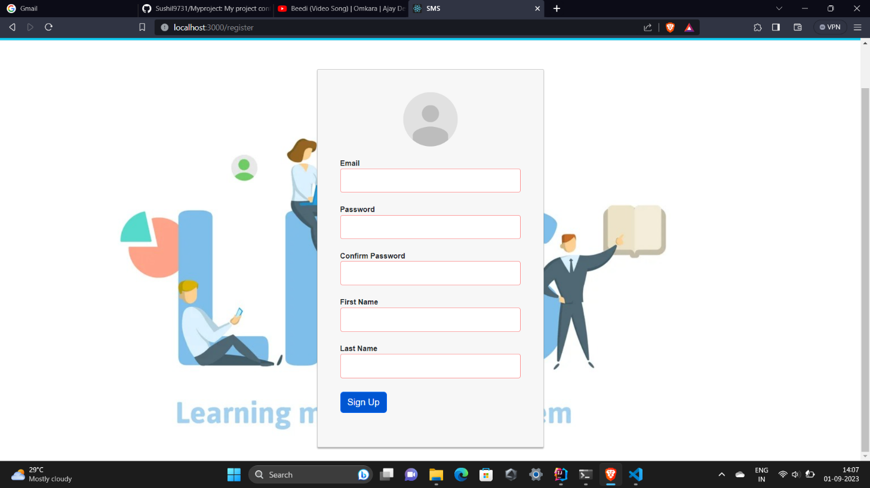

**8.4.2 Students Login Page**

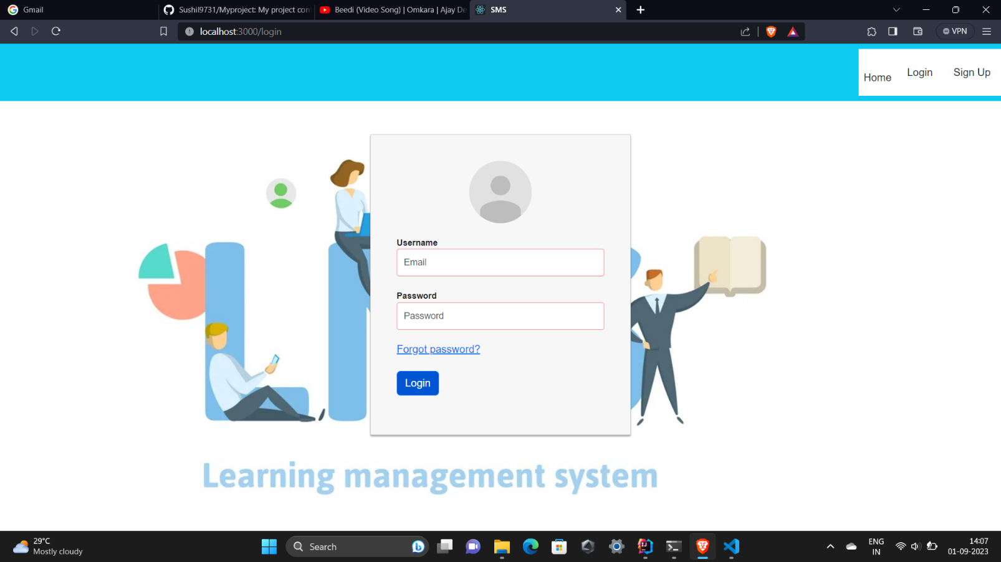

**8.4.3 Students Profile Page**

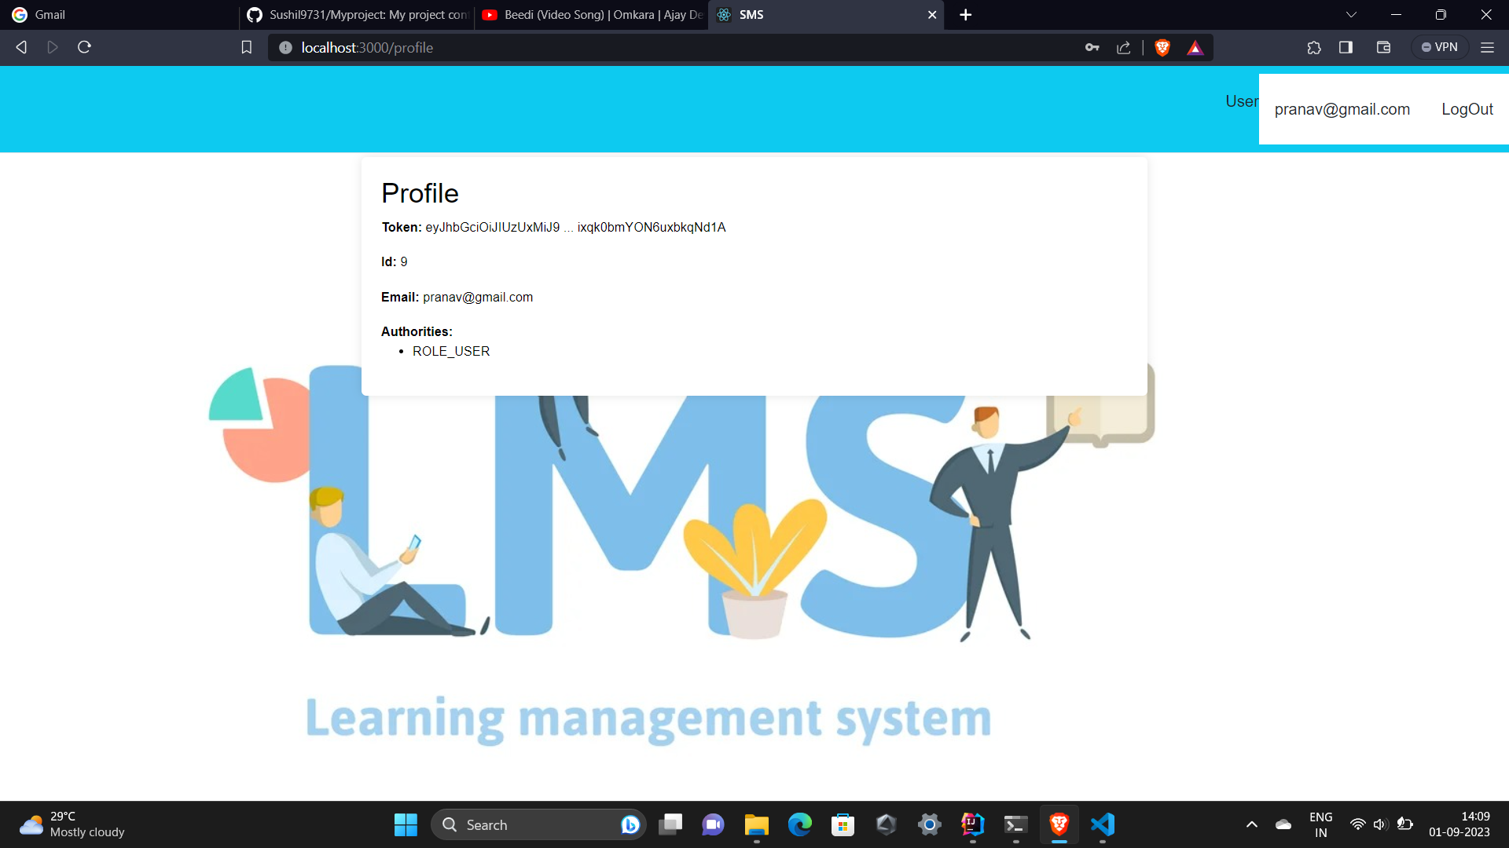

**8.4.3 Students D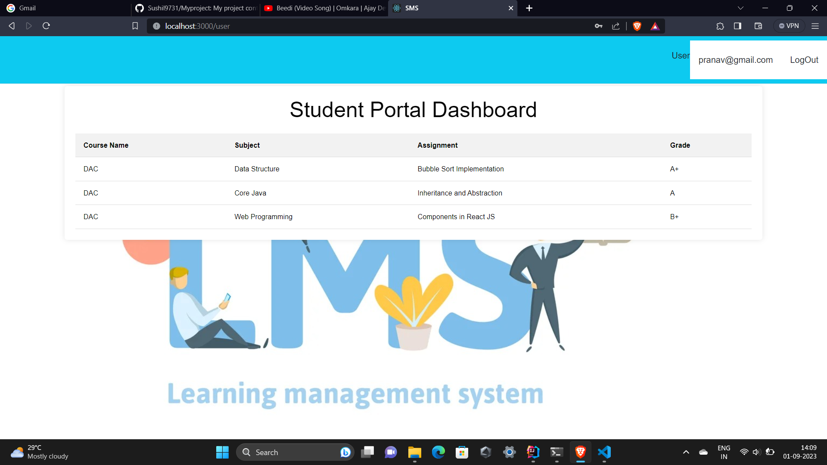ashboard**

**9. CONCLUSION AND FUTURE SCOPE**

Learning Management System provides a better solution to managing daily activities of any campus or institute. It helps Trainers to get benefits of effective and virtual learning as well as for Students too.

Our System provides a very user-friendly platform where Students can easily see daily schedule and course material for studies and for Teachers helps in virtual learn

* **Future Scope:** 
  1. In the future, we can make our project even better by using React JS and Bootstrap together. This will help us improve how the project looks and how users interact with it. We can make the project more attractive and easier to use by enhancing the designs and adding interactive elements.
  2. Also, we can work on the important parts of the project to make them work even smarter. By using Spring Boot and React JS more, we can add more functionalities using crud operations if more time and resources are provided. This may include functionalities of teacher to add submission tasks and attendance reports of students. On similar lines functionalities of students can be improved too.
  3. So, in the end the future of our project is about making the application more and more practical in terms of user inter-action and achieve the goal of ease of learning. And by focusing on the important parts, we can use technology to make our project suitable for multiple educational institutions.